**Accessible Design – Introduction to Web Accessibility**

**UI/UX Design Option 2**

**Tomowork Talent Accelerator Programme (TAP)**

**Introduction**

Welcome to Accessibility Design, Option 2 of the UI/UX Design Track! In the upcoming skills-based economy, industry recognised certifications play a pivotal role in representing the skills you have. In our TAP, all participants aim to complete at least two learning tracks. Below are the five learning tracks in TAP:

1. Financial Markets
2. Sustainability
3. Data Analytics
4. Digital Marketing
5. UI/UX Design
   1. UIUX Design (Option 1)
   2. **Accessibility Design (Option 2)**

**What is Accessible Design?**

Accessible Design centres around making your websites and  
apps work well for people with disabilities, meeting international standards, and providing a better user experience for everyone.

**Why Accessible Design?**

An estimated 1.3 billion people – or 16% of the global population – experience a significant disability today[1]. Today, only 1 in 10 people in need have access to assistive technology due to high costs and a lack of awareness, availability, trained personnel, policy, and financing[2]. Accessibility is hence essential for individuals and organizations that want to create high-quality websites and apps – and not exclude people from using their products and services.

**Why this course?**

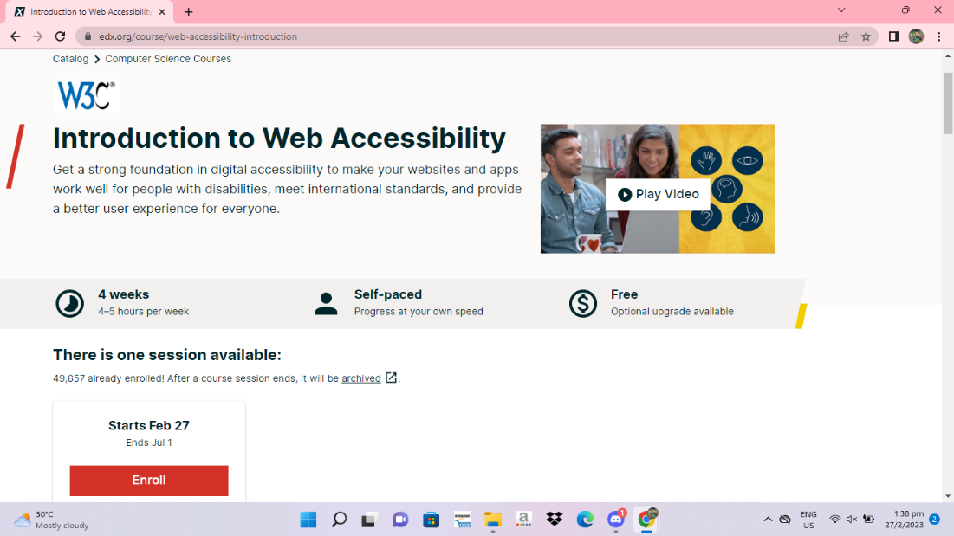

It is a 100% online self-paced course that can be completed in 4 weeks at 4-5 hours per week. Over 49,000 students have already enrolled.

This course gives you the foundation in accessibility you need to excel in digital professions. It is designed for:

* Developers
* Designers
* Content authors
* Project managers
* People with disabilities
* And others

In this course, you will learn about the international standards for web accessibility from the W3C. You will also learn how people with disabilities use different assistive technologies and adaptive strategies, the business benefits of web accessibility, and where to find W3C resources on implementing accessibility.

**How do I earn a certificate of completion?**

You can get a downloadable certificate upon completion of the course requirements.

**What about the fees?**

The W3C course on edX costs $99 USD for the certificate. You will need to pay first when starting the course. Once you obtain the certificate upon completion, TomoWork will fully reimburse the amount you paid.

For any questions regarding your learning track, please ask TAP Programme Director. Good luck on your learning journey!

**TAP Co-Programme Directors**

Mr Mike Momota

E: [mike@tomowork.org](mailto:mike@tomowork.org)

Mr William Wong

E: [william@tomowork.org](mailto:william@tomowork.org)

1. “Disability.” World Health Organization. World Health Organization, Dec 2, 2022. <https://www.who.int/news-room/fact-sheets/detail/disability-and-health>.
2. World Health Organization. (2018, May 18). *Assistive technology*. World Health Organization. Retrieved February 27, 2023, from <https://www.who.int/news-room/fact-sheets/detail/assistive-technology>